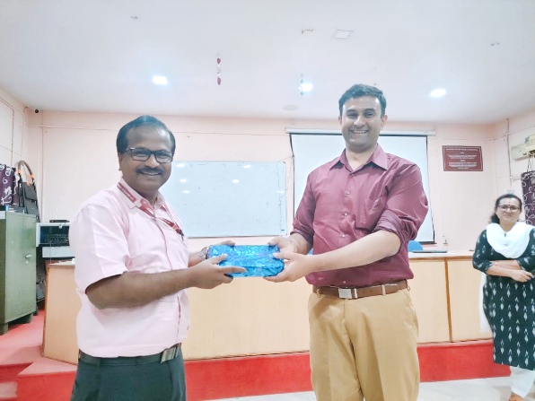

**MoU with Maker Bhavan Foundation, USA**

Mr. Sandeep Natekar  
Sr. Program Manager - Tinkerers' Lab

(On his visit to SCTCE)

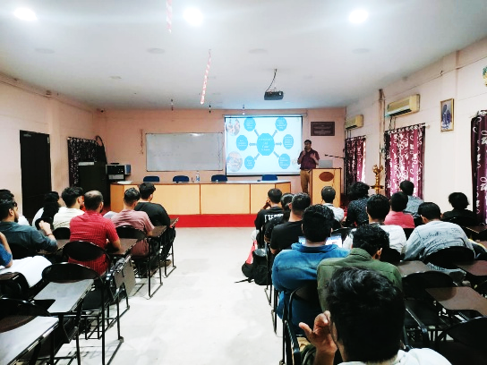

* SCTCE will receive donation equipment as an in-kind donation towards the establishment of a Tinkerer’s Lab at **SCTCE**, which will provide an avenue for students to learn in hands-on mode, after working hours, preferably 24x7.
* SCTCE will receive equipment worth INR **30** Lakhs (including GST) only. This donation will be in the form of equipment worth two tranches of INR **15** Lakhs each.
* Will get financial support of 2 lakhs for a maximum of 2 years, for meeting the expenditure for consumables.
* MBF will provide SCTCE TL users and human resources access to the MBF’s TL network and resources for mentoring and collaboration purpose.
* Will enable to conduct a series of workshops, courses, boot-camp and teacher training programs conducted by LEAP (Learning Engineering by Activity through Projects) Program of the IIT Madras Incubation Cell (IITM IC).
* 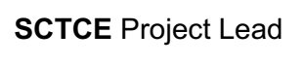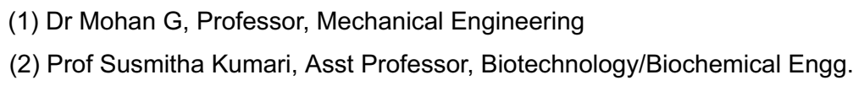The TL facility along with the LEAP programs will promote a “Learn by Doing” and hands-on technical skills that will improve student-learning outcomes and help the students in acquiring industry-relevant skills and abilities.